Experiment: 9

Massive MIMO Capacity vs SNR and Gain Using MATLAB

Aim
To analyze the performance of a Massive MIMO system by studying channel capacity, signal-to-noise ratio (SNR), and antenna gain using MATLAB.

Objectives
Objective – 1: Analyze Channel Capacity (bps/Hz)
Analyze the channel capacity of a Massive MIMO system for different signal-to-noise ratio (SNR) values using MATLAB. Observe how channel capacity increases with improving signal quality
based on the Shannon capacity principle.
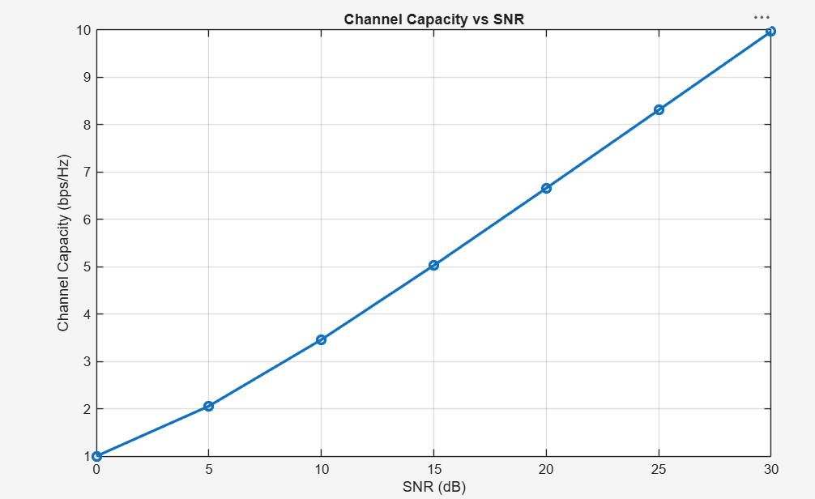

Objective – 2: Compare Signal-to-Noise Ratio (SNR) (dB)
Compare the signal-to-noise ratio for different communication scenarios using MATLAB. Analyze the effect of SNR on the quality and reliability of wireless communication in Massive
MIMO systems.
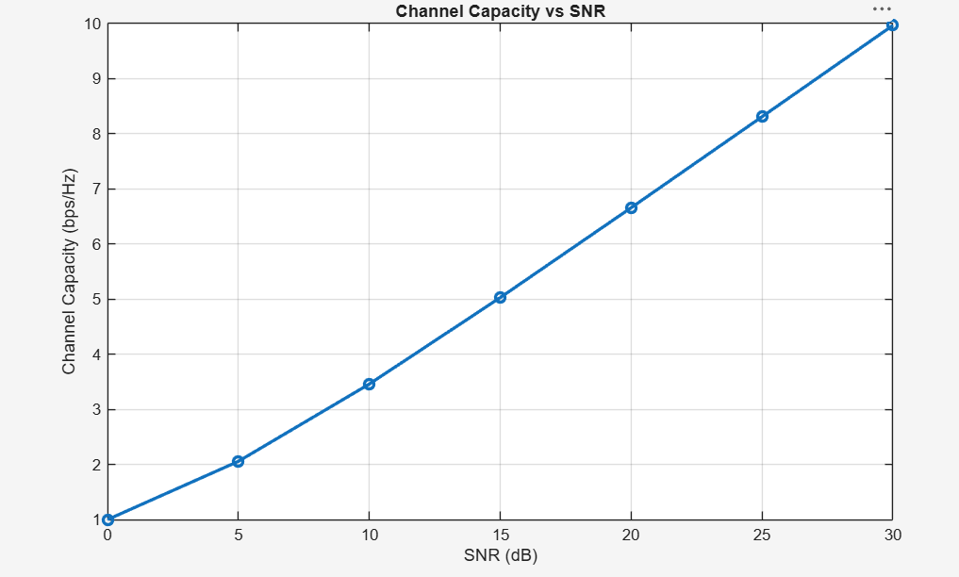
Objective – 3: Analyze Antenna Gain (dB)
Analyze the antenna gain achieved by varying the number of antenna elements in a Massive MIMO system using MATLAB. Observe how increasing the antenna array size improves
directional gain and enhances communication performance.
